Question 1

Part 1.
N=256; M=400; %% Over-sample for error checking
L = pi; d=1; d2=d*d;
The above lines set the number of Fourier modes and Legendre points, as well as the domain length and operator coefficients on u and u’’.
[Ah,Bh,Ch,Dh,z,w]=semhat(M);
Ab = (2/L)*Ah; Bb = (L/2)*Bh; Ib = eye(M+1); R = Ib(2:end-1,:);
A=R*Ab*R’; B=R*Bb*R’; H = d2*A + B;
The above lines call semhat, a function which computes the stiffness, mass and convection matrices for a 1D single Spectral Element. In addition, semhat returns the GLL points and weights through a call to zwgll. R is a restriction matrix to apply homogenous Dirichlet boundary conditions.
The resulting A and B matrices are the stiffness and mass matrices, which are constructed into H, the Helmholtz matrix.
z=L*(1+z)/2; w=L*w/2; % Scale points and weights to [0,L]
xb=z; fb=1+0*xb; % Set RHS for Legendre spectral soln
us= R’*(H\(R*Bb*fb)); % Solve Legendre system
These lines of code set up the forcing function for the Legendre spectral solution. Then, the Helmholtz problem is solved for the coefficients.
plot(xb,us,’k-’,’linewidth’,1.4); hold on;
Plots Legendre solution.
uf=0*xb; %% Initialize Fourier solution on GLL pts
for k=1:2:N; k1=k+1;
sk = sin(k*xb);
Fourier Sin series is used, looking for solution on the same points that we used for Legendre so we can compare.
% fk = 2*(w’*sk)/(2*pi); % 2 in numerator because integrate over [-pi,pi]
fk = 2/(k*pi); % 2 in numerator because integrate over [-pi,pi]
The fourier coefficients for a square wave are pre-computed here.
uk = 2*fk./(1+d2*k*k); % 2 in numerator because +/- k mode.
uf = uf + uk*sk;
Add contribution from the kth component of the fourier series to the overall values.
ef=uf-us;
em(k1/2)=max(abs(ef));
Compute error compared to Legendre solution (L_inf)
ef2(k1/2) = sqrt(ef’*Bb*ef/pi);
Energy norm of error (L2)
nN(k1/2) = k;
if k==1; plot(xb,uf,’r--’); end;
if k==3; plot(xb,uf,’g--’); end;
if k==5; plot(xb,uf,’b--’); end;
end;
The above lines and the rest of the code is just for plotting purposes.
I ran this code and also added the exact solution to the plot, just to make sure that it lined up with the M=400 Legendre.
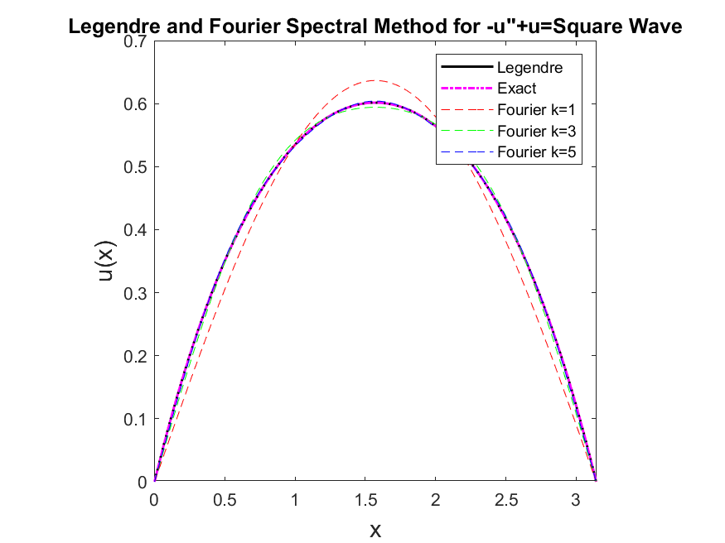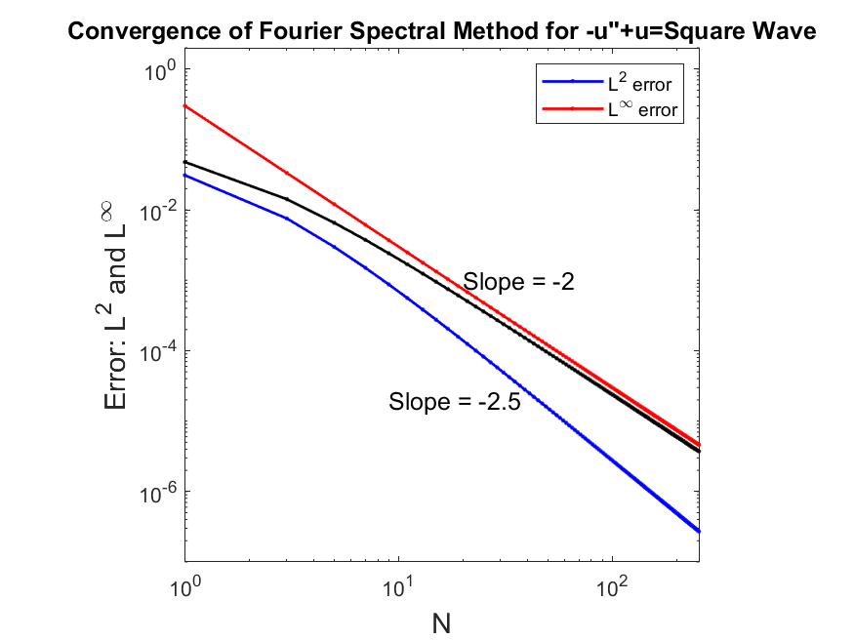

Part 2.
Consider the problem
$$-u^{''}+u=πx-x^{2}$$
The odd Fourier coefficients f_k are then:
$$f_{k}=\frac{8}{πk^{3}}$$
(ChatGPT figured out these coefficients).
The corresponding plots are:
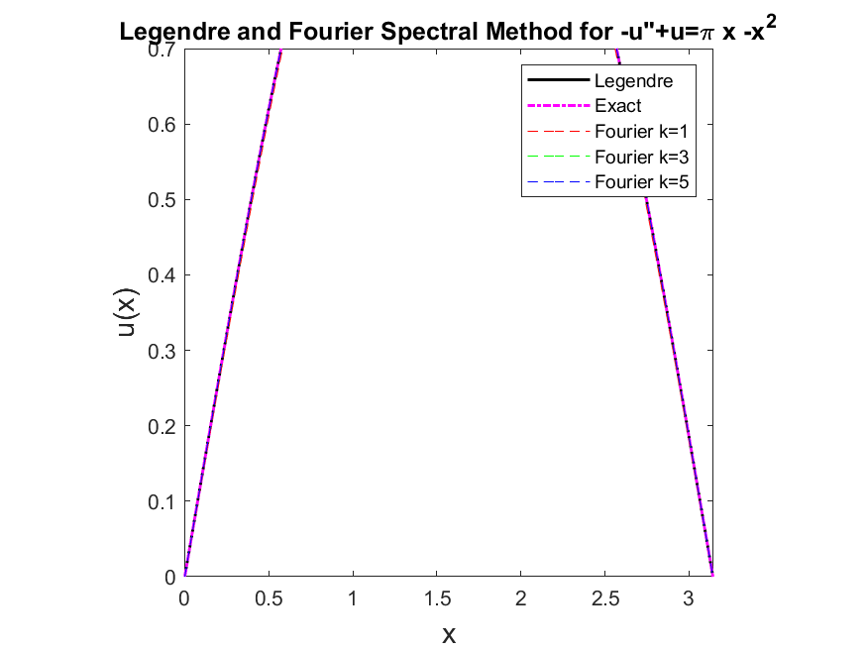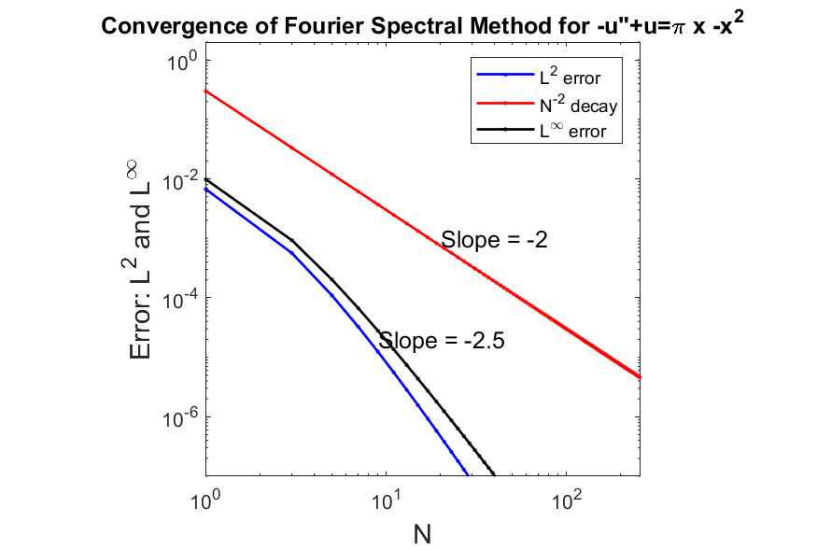
These demonstrate better than power-law convergence (ie exponential convergence) which is expected for a smooth function.

Question 2.

